**Dominic Townsend**

**Brief 3 – Instanced Scrolling Material**

**Documentation**

**Overview:**

This project uses a tile-able texture as a prefab that moves down on instantiation. The prefab is spawned in regular intervals above the camera in order to give the impression that the material is scrolling infinitely. After an instance of the material leaves the camera’s view, it gets deleted from the scene.

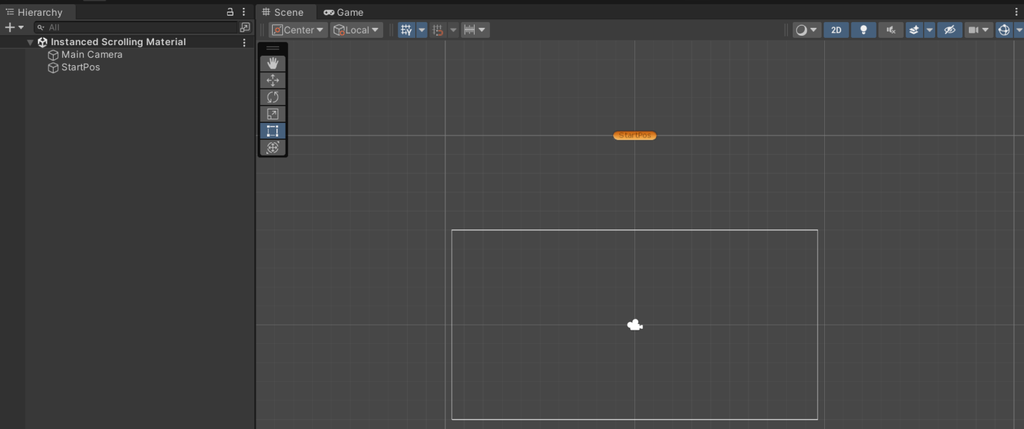

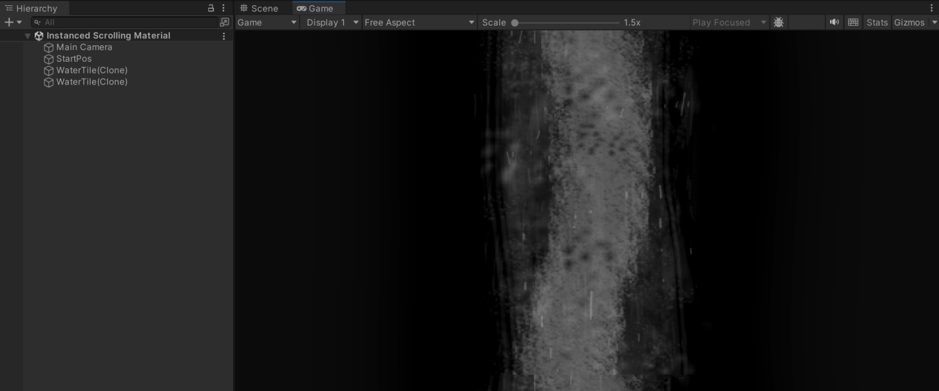

**Assets:**

**Prefabs:**

* WaterTile.prefab

**Other Assets:**

* WaterTile.png

**Scripts:**

**Script 1 – MaterialMovement.cs:**

This script is attached to the WaterTile prefab, and makes it move down the screen at a set speed. As well as this, it detects when an instance of the object goes below the camera’s scope and destroys it.

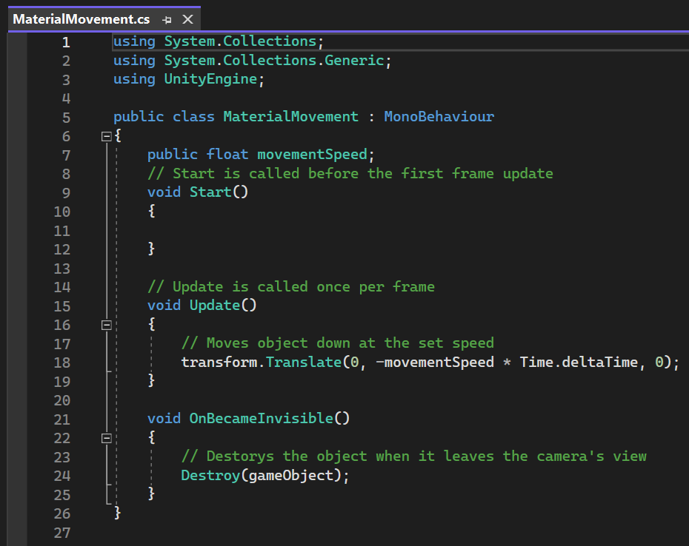

**Script 2 – SpawnPrefab.cs:**

This script instantiates WaterTile objects at a certain position above the camera at a rate determined by a constant value set within the Unity editor.

